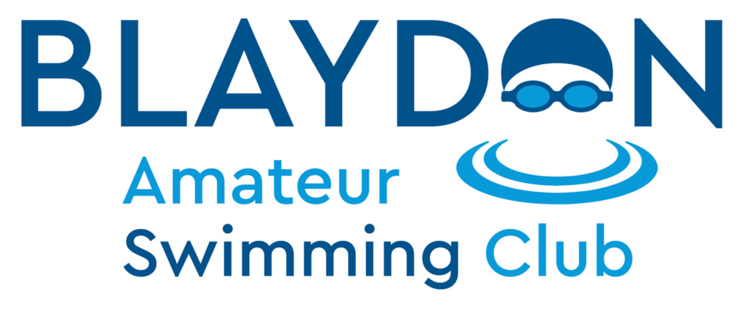

**Code of Conduct for Coaches**

This code is something that you as a member of the coaching team should refer to in relation to your rights in your role, the respect you should expect but also that which you demonstrate to all members, what is expected of you in terms of listening and being listened to and your behaviour as a member of the club.

As a coach, you have the right to:

• Be supported in your role and respected and treated fairly by the club.

• Be informed of Wavepower and appropriate reporting procedures.

• Know who the Welfare Officer(s) is/are and how to contact them.

• Be informed of the club complaints process and who to contact at the club.

• Be aware of the club rules and procedures.

• Be involved and contribute towards decisions within the club.

• Have access to ongoing training and CPD in all aspects of your role.

As a coach in Blaydon ASC we expect certain standards of behaviour. By becoming a coach and therefore agreeing to this Coaches’ Code of Conduct you agree to:

| **Rules and Regulations** | **Actions** |
| --- | --- |
| Attendance | To inform coaches and club secretary of any absence via agreed communication system, e.g. WhatsApp group. |
| Adhere to the Swim England Equality and Diversity Policy | Not engage in any behaviour that constitutes any form of abuse.  Champion everyone’s right to take part and celebrate difference in our club or activity by not discriminating against anyone else on the grounds of gender, race, sexual orientation, faith, ability, or any other relevant characteristic. |
| Coaching | To follow the rules outlined in the Club Constitution.  Keep your coaching qualifications and CPD up to date.  Use positive and constructive methods when teaching and coaching and ensure programmes are appropriate for the age, ability and experience of the child.  Encourage children to behave in a positive manner and follow the rules of the club and sport. Challenge and address instances of poor, negative, aggressive or bullying behaviour amongst children.  Lead by example creating and promoting positive behaviour and a safe culture.  Adhere to any conditions for teaching and coaching under the pool hire agreement.  To follow the agreed planning season as put forward by the Head Coach.  Respect your position of trust to maintain appropriate boundaries and relationships with athletes.  To not use your position to obtain personal benefit or reward. |
| Follow regulations outlined by Swim England | Adhere to Swim England regulations. |
| Safeguarding | Adhere to and implement Wavepower  Refer all safeguarding and welfare concerns to the Welfare Officer.  Seek advice from the Welfare Officer where necessary. |
| Safety | Keep children safe in sessions with appropriate staffing ratios.  Use safe methods of instruction and techniques by putting athletes’ safety first.  Ensure you have a current Disclosure and Barring Service (DBS) certificate (renewable every three years).  Complete Swim England safeguarding training every three years.  Ensure any equipment used is fit for purpose, safe to use and accessible.  Record accidents in the Accident Book. Inform the head coach, Blaydon Leisure Centre and the guardians of the member. |

Breaches of the Code of Conduct will result in disciplinary action being taken against you by the club committee under the judicial. Continued issues and repeated breaches may result in your dismissal from the club. Any criminal offence will be reported to Police and any other relevant authority, by the club.